

Assessment Cover Page

Student Full Name: Badgirmaa Nasanbuyan
Student Number: 2026637
Module Title: Strategic Thinking
Assessment Title:
Predicting Career Advancement and Internal Mobility in the US TMT Sector using Machine learning
Lecturer/Supervisor: Muhammad lqbal
Assessment Due Date: 25/10/2026

Contents
Introduction 1
Aim and Objectives 1
General objective: 1
Specific objective: 2
Scope 2
Included: 2
Excluded: 2
Methodology 2
Architecture diagram picture-1. 3
Data Sources 4
Expected Outcomes 4
Project Timeline 4
Project timeline table-2. 4
Ethical and Legal Considerations 4
References 5
Appendix 6

Use of AI Tools

I acknowledge the use of Claude for the purpose of creating the ( Ficture1, System Architecture), and receiving feedback and Microsoft Word formatting guidance. I reviewed and edited all AI-generated content.”
Declaration
By submitting this assessment, I confirm that I have read the CCT policy on academic misconduct and understand the implications of submitting work that is not my own or does not appropriately reference material taken from a third party or other source.
I declare it to be my own work and that all material from third parties has been appropriately referenced.
I further confirm that this work has not previously been submitted for assessment by myself or someone else in CCT College Dublin or any other higher education institution.


Introduction

The TMT (Technology, Media, and Telecommunications) sector in the United States faces intense competition for rare digital talent, with a skills shortage that constrains industry growth. Traditional labor market analysis often views career progression as a direct, linear path. This perspective fails to fully capture the complex ways in which professionals transition between sub-sectors—for instance, moving from the telecommunications industry into artificial intelligence. Understanding these shifts is crucial, as skill gaps and unemployment place significant strain on economic productivity.
This project aims to develop a system that predicts talent mobility within the TMT (Technology, Media, and Telecommunications) sector by leveraging historical workforce data. Investigating this issue holds significant scientific value, as it shifts the field of labor economics from merely explaining current conditions toward forecasting the future. The data generated by this project will serve as a foundation for universities to update their curricula, while also enabling EdTech platforms and career counselors to provide data-driven guidance. Furthermore, it will assist companies in developing long-term human resource strategies and help individual professionals uncover new, previously hidden career opportunities
Problem Definition
Despite rapid macro-level shifts within the TMT (Technology, Media, and Telecommunications) sector, the labor market functions inefficiently due to a lack of data for predicting career transitions. This gives rise to four primary issues within the labor market:
- Individual Professionals: Because job seekers often fixate solely on traditional vertical advancement, they fail to recognize hidden opportunities for lateral moves within their industry—moves that would align well with their existing skill sets—and consequently find themselves at a career dead end.
- Human Resources Strategy: Because companies lack insight into the dynamics of workforce movement between sub-sectors, their long-term planning is often flawed. Furthermore, by remaining fixated on "static recruiting"—prioritizing candidates with pre-existing experience—they miss opportunities for reskilling their own workforce.
- Labor Market: The inability to foresee workforce transitions exacerbates the "skills gap," leading to increased structural unemployment and a loss of productivity.
- Education System: Universities and colleges rely on outdated, static data, which hinders the development of curricula aligned with emerging career pipelines and limits the provision of data-driven career guidance.

Aim and Objectives

General objective:
To develop a data analytics framework that forecasts macro-level career mobility flows within the US TMT sector using machine learning algorithms, thereby optimizing labor market alignment and career architecture.

Specific objective:
- Collect and clean historical career trajectory and job data for professionals within the TMT (Technology, Media, and Telecommunications) sector in the United States.
- Calculate a "Job Skill Similarity" (JSS) matrix to determine mathematical similarities between jobs and the overlap of required skills.
- Develop and validate a machine learning model (utilizing Markov chains and Graph Neural Networks) capable of predicting future multi-directional workforce flows.
- Evaluate the model's outputs—based on historical data—and develop an interactive dashboard that visualizes career pathways for industry stakeholders.

Scope

Included:

Limited to the U.S. labor market, specifically within the TMT (Technology, Media, and Telecommunications) sector.
Type of Transition: Research on vertical career advancement (promotion) and lateral mobility.
Develops a predictive model focused on probabilistic workforce flows at a macro level.

Excluded:
Internal promotion processes within a company or the evaluation of an individual employee's job performance.
Labor markets in countries outside of the United States.
Sectors entirely unrelated to the TMT (Technology, Media, and Telecommunications) industry (e.g., traditional agriculture, heavy industry, etc.—provided there is no direct movement of talent from these sectors into TMT).
Real-time job placement services or automated recruitment systems (as opposed to general HR/recruitment apps).

Methodology
- Random Forest/XGBoost provides a supervised, feature-based classifier for predicting the destination role.
- GNN supplies structural embeddings that can either stand alone or be fused with tabular features to enrich the classifier.
- Markov Chains + NetworkX add a sequence-aware, graph-based view of career pathways, complementing pointwise classification with transition dynamics probabilities, then build directed career-path graphs.

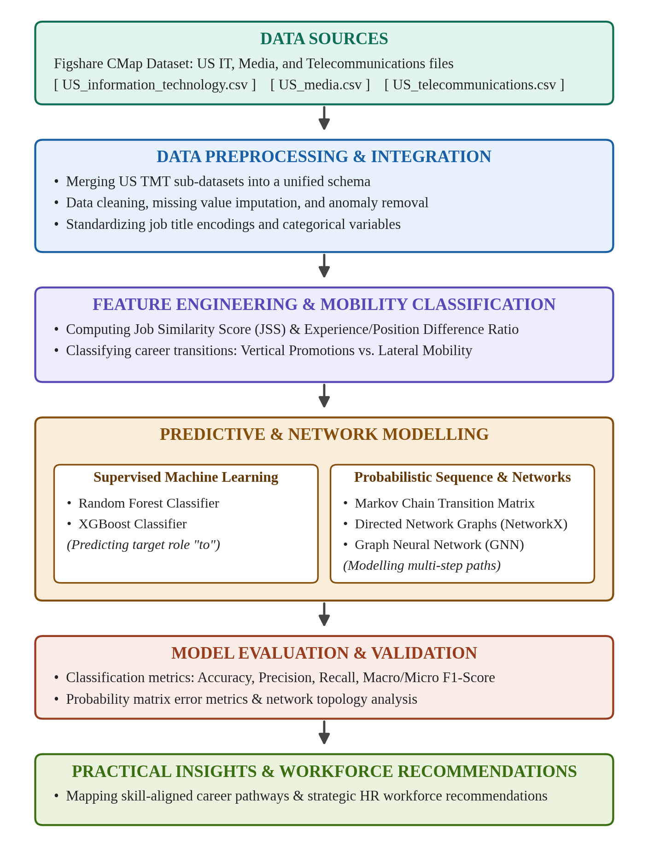
Architecture diagram picture-1.

Data Sources
The data for this project comes from a public website called Figshare. This dataset is based on professional resumes, but all personal information has been removed for privacy. It is designed to help researchers study job market trends, career paths, and job promotions in different industries.
Figshare | https://figshare.com/articles/dataset/CMap_a_database_for_mapping_job_titles_sector_specialization_and_promotions_across_24_sectors/28229633
Project timeline table-1.

Expected Outcomes
By the end of Semester 2, this project will deliver a cleaned US TMT (Technology, Media and Telecom) career dataset with vertical and horizontal transitions labelled, and an exploratory analysis of transition frequency, JSS and EPDR. It will also produce Random Forest and XGBoost models that predict a person's next job role, evaluated with Accuracy, Precision, Recall and F1-Score, GNN based structural graph embeddings, a Markov chain probability matrix and a NetworkX career pathway graph. Everything will be documented in a final academic report with the system architecture, results and practical recommendations.

Project Timeline
Phase/ Semester | 1-2 week | 3-4 week | 5-6 week | 7-8 week | 9-10  week | 11-12  week
Phase/ Semester | Semester -1 |  |  | Semester-2
Phase 1: Research Design & Proposal
Phase 2: Data Collection & Preprocessing
Phase 3: Index Calculation & Classification
Phase 4: ML Model Development
Phase 5: Markov Transition & NetworkX
Phase 6: Evaluation & Final Report

Project timeline table-2.

Ethical and Legal Considerations
Privacy: Figshare data is fully anonymized and aggregated, so it does not contain personally identifiable information (PII) or internal company secrets.
License: In accordance with the open-access terms of Figshare and the U.S. Bureau of Labor Statistics (BLS) SOC system, the data is to be used exclusively for academic research and educational purposes.

References

Breiman, L. (2001) ‘Random forests’, Machine Learning, 45(1), pp. 5–32.
Chen, T. and Guestrin, C. (2016) ‘XGBoost: a scalable tree boosting system’, in Proceedings of the 22nd ACM SIGKDD International Conference on Knowledge Discovery and Data Mining. San Francisco, 13–17 August. New York: ACM, pp. 785–794.
Hagberg, A.A., Schult, D.A. and Swart, P.J. (2008) ‘Exploring network structure, dynamics, and function using NetworkX’, in Proceedings of the 7th Python in Science Conference (SciPy 2008). Pasadena, 19–24 August, pp. 11–15.
Scarselli, F., Gori, M., Tsoi, A.C., Hagenbuchner, M. and Monfardini, G. (2009) ‘The graph neural network model’, IEEE Transactions on Neural Networks, 20(1), pp. 61–80.
Norris, J.R. (1997) Markov chains. Cambridge: Cambridge University Press.
Pedregosa, F. et al. (2011) ‘Scikit-learn: machine learning in Python’, Journal of Machine Learning Research, 12, pp. 2825–2830.
Subhani, S., Memon, S.A. and AlShebli, B. (2025a) ‘CMap: a database for mapping job titles, sector specialization, and promotions across 24 sectors’, Scientific Data, 12(1), pp. 1–18. Available at: https://doi.org/10.1038/s41597-025-05526-3 (Accessed: 22 October 2026).
Subhani, S., Memon, S.A. and AlShebli, B. (2025b) CMap: a database for mapping job titles, sector specialization, and promotions across 24 sectors. Figshare. Available at: https://figshare.com/articles/dataset/CMap_a_database_for_mapping_job_titles_sector_specialization_and_promotions_across_24_sectors/28229633 (Accessed: 22 October 2026).
U.S. Bureau of Labor Statistics (2018) 2018 Standard Occupational Classification system. Available at: https://www.bls.gov/soc/ (Accessed: 22 October 2026).

Appendix

Request for system architecture diagram

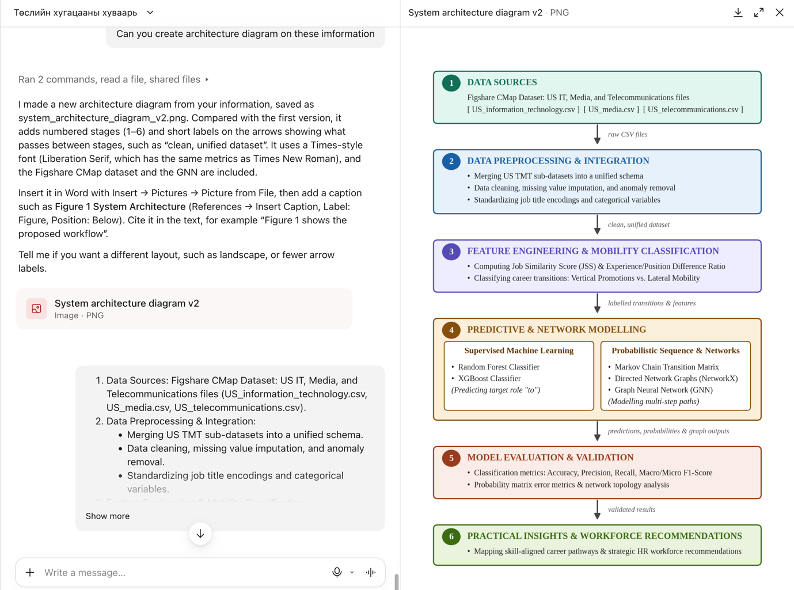

Ethical Machine Learning Research Student Researcher Capstone Project Ethics Form

As a student researcher in the capstone project, you are vital in ensuring the project is conducted ethically and without bias. Before you embark on the capstone project, please carefully read and understand the following information.
By conducting the capstone project, you will be actively engaged in the following research activities:
- Data analysis and preprocessing.
- Training and evaluating machine learning models.
- Drawing conclusions on the machine learning models and the dataset, nothing else.
The capstone project will comprehensively examine machine learning models without introducing biases or negatively affecting vulnerable populations in society. The focus is on improving the fairness and accuracy of the results obtained from the machine learning models. The focus is on the models themselves and the dataset without delving into social work, bias or anthropology. Use deductive reasoning on the model outcomes.
Yes | No | As a student researcher, your responsibilities include:
Yes |  | Adhering to ethical guidelines provided for data handling and analysis.
Yes |  | Data is anonymised, and personal identifiers will be removed to protect the privacy of individuals.
Yes |  | Ensure that the research does not introduce bias and avoids adverse effects on the vulnerable in society and minors.
Yes |  | Focus on evaluating and improving machine learning model accuracy and results.

I have read and understood the information provided in this ethics form, and I agree as a student researcher to abide by the ethics outlined in this form in the capstone project. I understand that my role will focus on machine learning models and dataset analysis and will not involve social work, health and care, vulnerable social groups or anthropology (no personal interviews of human subjects).
If you have any questions or concerns or require clarification on the capstone project's ethics, please contact James Garza at jgarza@cct.ie.

Student Name (printed): Badgirmaa.N_

Student Number: _____2026637___

Student Signature: __________________________

Date: 24/10/2026

